**Activity Sheet Name Chapter 6, Lesson 3**

**Forming a Precipitate Date**

# DEMONSTRATION

1. **Your teacher combined two clear colorless solutions. One was a sodium carbonate solution and the other was a magnesium sulfate solution. Do you think a chemical reaction occurred when these two substances were combined?**

**Why or why not?**

1. **What is a precipitate?**

# ACTIVITY

## Question to Investigate

How do you know when a precipitate is formed in a chemical reaction?

## Materials for Each Group

* 1. Baking soda
  2. Calcium chloride
  3. Water
  4. Graduated cylinder
  5. Measuring spoon (½ teaspoon) or balance
  6. 2 clear plastic cups
  7. Masking tape
  8. Pen

## Procedure

1. Use masking tape and a pen to label 2 plastic cups *Baking Soda Solution* and *Calcium Chloride Solution*.
2. Use a graduated cylinder to add 20 mL of water to each cup.
3. 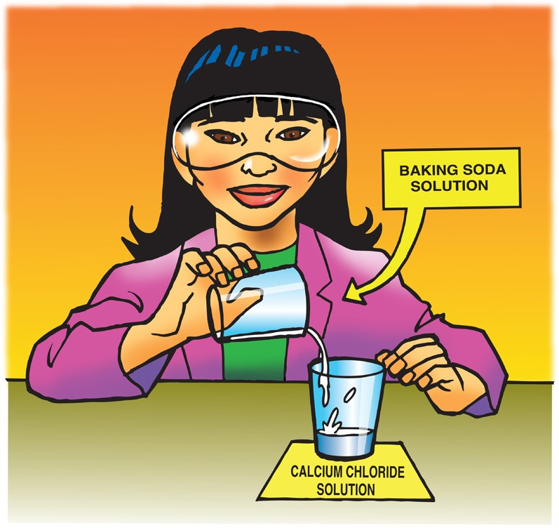Add 2 g (about ½ teaspoon) of calcium chloride to the water in its labeled cup. Swirl until as much of the calcium chloride dissolves as possible.
4. Add 2 g (about ½ teaspoon) of baking soda to the water in its labeled cup. Swirl until as much of the baking soda dissolves as possible. Some undissolved baking soda may remain in the bottom of the cup.
5. Carefully pour the baking soda solution into the calcium chloride solution. Try not to pour in any undissolved baking soda. Observe.
6. **What do you observe when you combine baking soda solution and calcium chloride solution?**
7. **How do you know that a chemical reaction occurs when you combine baking soda solution and calcium chloride solution?**

# EXPLAIN IT WITH ATOMS & MOLECULES

1. **Look at the chemical equation for the reaction between calcium chloride and sodium bicarbonate and answer the following questions.**

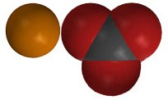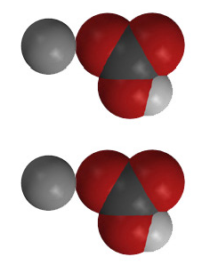

+

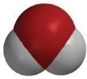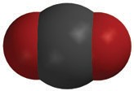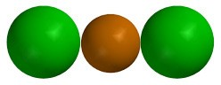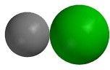

+

+

+

**CaCl2**

calcium chloride

**2NaHCO3**

sodium bicarbonate

**CaCO3**

calcium carbonate

**2NaCl**

sodium chloride

**H2O**

water

**CO2**

carbon dioxide

**What gas is produced in the chemical reaction?**

**What do you think is the precipitate?**

|  |  |  |
| --- | --- | --- |
| **How many of each type of atom appears on each side of the chemical equation?** | | |
| **Atom** | **Reactant side** | **Product side** |
| Calcium |  |  |
| Chlorine |  |  |
| Sodium |  |  |
| Hydrogen |  |  |
| Carbon |  |  |
| Oxygen |  |  |

# ACTIVITY

## Question to Investigate

Can you separate the calcium carbonate from the rest of the products?

## Materials for Each Group

* Coffee filter or paper towel
* Tall clear plastic cup

## Procedure

1. 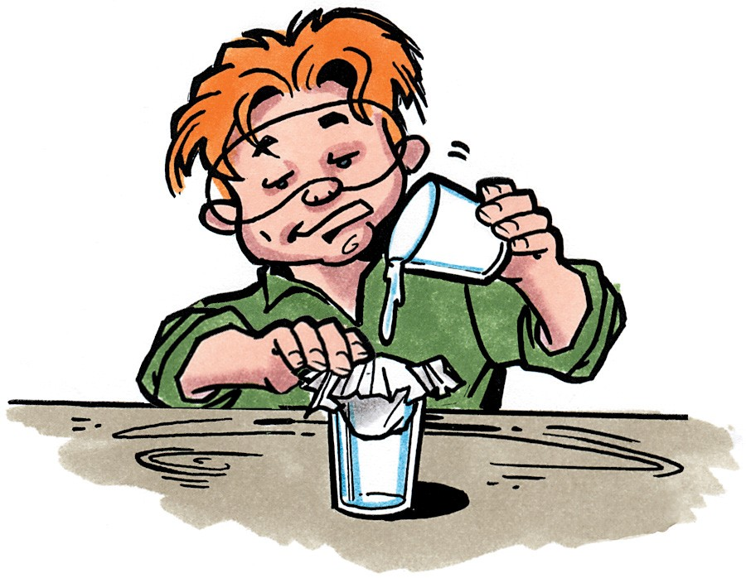Use a large enough coffee filter (or paper towel) so that you can push it about ⅓ of the way into the cup and still have enough left to hold it around the outside of the cup.
2. While holding the coffee filter in place, pour the products into the center of the coffee filter.
3. Allow the liquid to drip through the filter. This may take 5-10 minutes.
4. Set the precipitate aside and allow the water to evaporate.
5. **Is filtering the calcium carbonate and allowing the water to evaporate a chemical change or a physical change?**

**Why?**

# TAKE IT FURTHER

Your teacher added drops of ammonia to copper II sulfate solution.

1. **How can you tell that something new was made when the copper II sulfate and ammonia reacted?**
2. **How can you tell that something new was made when these substances reacted with hydrogen peroxide?**
3. **Use objects such as gum drops, beads, M&Ms, Legos, or other small objects to represent the atoms in two of the three chemical reactions you have covered in chapter 6. The three chemical equations are written below. Tape or glue the objects to poster board and write down the chemical formula for the reactants and products.**

**CH4**

methane

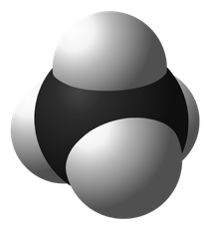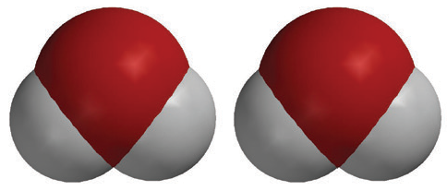

**2O2**

oxygen

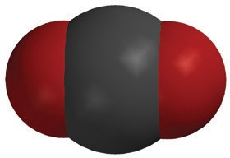

**CO2**

carbon dioxide

**2H2O**

water

+

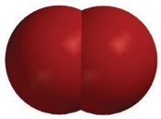

+

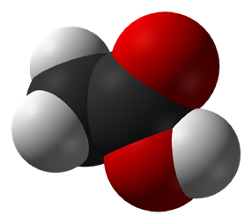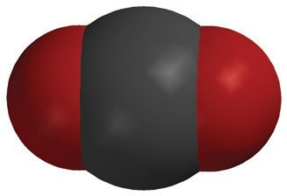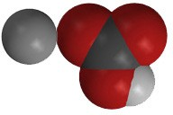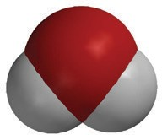

+

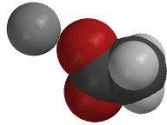

+

+

**C2H4O2**

acetic acid

**NaHCO3**

sodium bicarbonate

**NaC2H3O2**

sodium acetate

**H2O**

water

**CO2**

carbon dioxide



+



+

+

+

**CaCl2**

calcium chloride

**2NaHCO3**

sodium bicarbonate

**CaCO3**

calcium carbonate

**2NaCl**

sodium chloride

**H2O**

water

**CO2**

carbon dioxide